1. Entities and Data Stores
USER: The primary external entity interacting with the system to add, edit, delete, and search contacts
CLOUD SYNC SERVICE: An external service responsible for synchronizing contact data between the local system and the cloud
BACKUP SERVICE: An external service responsible for storing and providing backup data for the phone book system.
D1 CONTACT DATABASE: The internal data store for all contact and backup data

2. Context Diagram (0-Level)
This level represents the 0.0 Phone Book Management System as a single central process interacting with three external entities.
USER Interchanges:
The system receives Add/Edit/Delete/Search Request from the user. It outputs Contact Details, Search Results, and Confirmation Message/Error to the user.
Cloud Interchanges:
The system sends Upload Updates to the Cloud Sync Service. It receives Remote Contact, Sync Status, and Restore Data from the service.
Backup Interchanges:
The system sends a Backup Request to the Backup Service. The service returns Backup Data to the system.

3. Level-1 Decomposition
At this level, the Phone Book Management System is decomposed into four core processes to illustrate how contact data is handled internally.
Process | Core Function | Key Data Flows
1.0 Manage Contacts | Handles user requests to add, edit, or delete contact records. | Receives Add/Edit/Delete Request; writes or updates contact data in D1; returns Contact Details and Confirmation Message/Error to the USER.
2.0 Search Contacts | Processes user search requests to find specific contacts. | Receives Search Request; retrieves Filtered Contact Details from D1; returns Search Results to the USER.
3.0 Perform Cloud Sync | Synchronizes local contact data with the remote cloud service. | Retrieves All Contact Data from D1; sends Upload Updates to Cloud Sync Service; receives Remote Contact/Sync Status/Restore Data; writes Restored Data to D1
4.0 Manage Backups | Manages the backup and restoration of contact data. | Receives Backup Request; retrieves Database Backup Data from D1; sends and receives Backup Data to/from the Backup Service; restores Restore Data to D1.

Level 0:
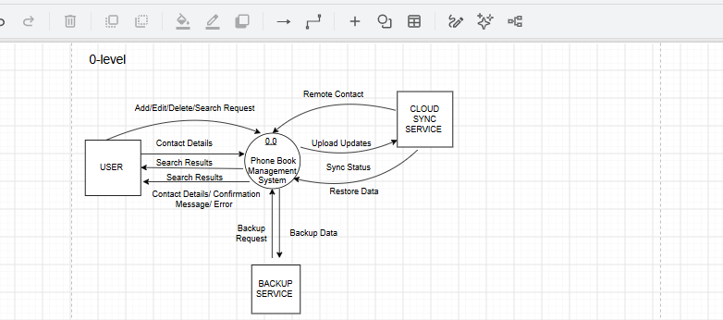

Level 1:
